FIND-S:

import csv

data = list(csv.reader(open('csv1.csv')))

hypothesis = data[1][:6]

for i, row in enumerate(data):

if row[6] == 'yes':

hypothesis = ['?' if row[j] != hypothesis[j] else hypothesis[j] for j in range(6)]

print(f"Instance {i}: {hypothesis}")

print("\nMaximally specific hypothesis:", hypothesis)

OUTPUT:

Instance 0: ['sunny', 'warm', 'normal', 'strong', 'warm', 'same']

Instance 1: ['sunny', 'warm', 'normal', 'strong', 'warm', 'same']

Instance 2: ['sunny', 'warm', '?', 'strong', 'warm', 'same']

Instance 3: ['sunny', 'warm', '?', 'strong', 'warm', 'same']

Instance 4: ['sunny', 'warm', '?', 'strong', '?', '?']

Maximally specific hypothesis: ['sunny', 'warm', '?', 'strong', '?', '?']

CANDIDATE ELIMINATION:

import pandas as pd

data = pd.read_csv('csv1.csv').values

s = data[0][:-1].copy()

g = [["?"] * len(s) for _ in range(len(s))]

for i, row in enumerate(data):

if row[-1] == "yes":

s = ['?' if s[j] != row[j] else s[j] for j in range(len(s))]

else:

for j in range(len(s)):

if s[j] != row[j]: g[j][j] = s[j]

g = [hyp for hyp in g if '?' in hyp][:2]

print("\nFinal Specific Hypothesis (s):", s)

print("\nFinal General Hypotheses (g):", g)

OUTPUT:

Final Specific Hypothesis (s): ['sunny', 'warm', '?', 'strong', '?', '?']

Final General Hypotheses (g): [['sunny', '?', '?', '?', '?', '?'], ['?', 'warm', '?', '?', '?', '?']]

DECISION TREE:

import pandas as pd

from sklearn import tree

import matplotlib.pyplot as plt

from sklearn.preprocessing import LabelEncoder

data = pd.read_csv('tennis.csv')

print(data.head())

label_encoders = {}

for column in data.columns:

if data[column].dtype == 'object':

le = LabelEncoder()

data[column] = le.fit_transform(data[column])

label_encoders[column] = le

print(data.head())

X = data.iloc[:, :-1] # Features

y = data.iloc[:, -1] # Target

clf = tree.DecisionTreeClassifier(criterion='entropy') # Use entropy to mimic ID3

clf = clf.fit(X, y)

plt.figure(figsize=(20, 10)) # Increase the size for better readability

tree.plot_tree(clf, filled=True, feature_names=X.columns, class_names=[str(cls) for cls in clf.classes_])

plt.show()

OUTPUT:

Unnamed: 0 Outlook Temperature Humidity Wind PlayTennis

0 0 Sunny Hot High Weak No

1 1 Sunny Hot High Strong No

2 2 Overcast Hot High Weak Yes

3 3 Rain Mild High Weak Yes

4 4 Rain Cool Normal Weak Yes

Unnamed: 0 Outlook Temperature Humidity Wind PlayTennis

0 0 2 1 0 1 0

1 1 2 1 0 0 0

2 2 0 1 0 1 1

3 3 1 2 0 1 1

4 4 1 0 1 1 1

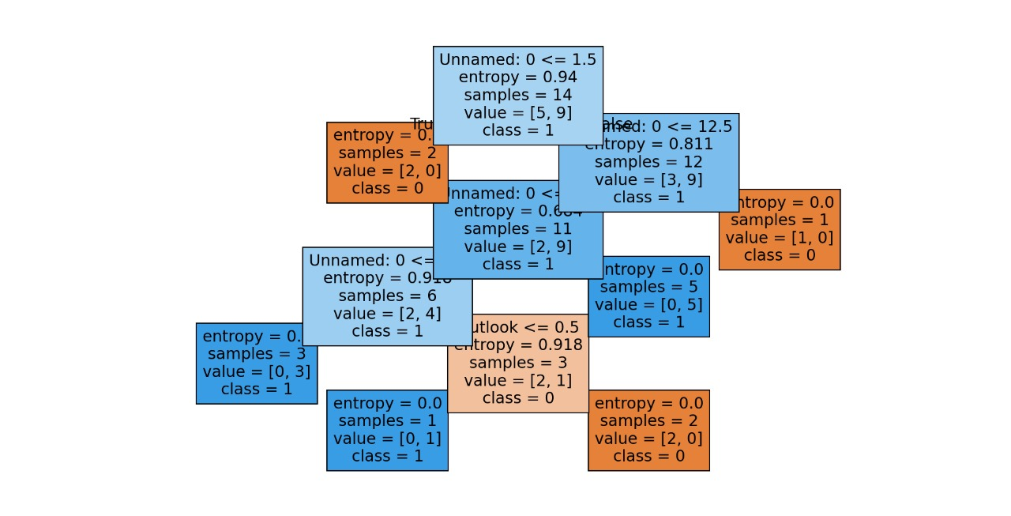

NAÏVE BAYES:

import pandas as pd

from sklearn.model_selection import train_test_split

from sklearn.naive_bayes import GaussianNB

from sklearn.metrics import accuracy_score, precision_score, recall_score

data = pd.read_csv('Titanic.csv').drop(['PassengerId', 'Name', 'Ticket', 'Cabin'], axis=1).dropna()

data['Sex'] = data['Sex'].map({'male': 0, 'female': 1})

data['Embarked'] = data['Embarked'].map({'C': 0, 'Q': 1, 'S': 2})

X, y = data.drop('Survived', axis=1), data['Survived']

X_train, X_test, y_train, y_test = train_test_split(X, y, test_size=0.2, random_state=42)

classifier = GaussianNB().fit(X_train, y_train)

y_pred = classifier.predict(X_test)

print(f'Accuracy: {accuracy_score(y_test, y_pred):.2f}')

print(f'Precision: {precision_score(y_test, y_pred):.2f}')

print(f'Recall: {recall_score(y_test, y_pred):.2f}')

OUTPUT:

Accuracy: 0.76

Precision: 0.73

Recall: 0.73

KNN:

import numpy as np

import pandas as pd

import matplotlib.pyplot as plt

from sklearn.neighbors import KNeighborsClassifier

from sklearn.model_selection import train_test_split

from sklearn.preprocessing import LabelEncoder

from matplotlib.colors import ListedColormap

df = pd.read_csv('Iris.csv')

X = df[['SepalLengthCm', 'SepalWidthCm']].values

label_encoder = LabelEncoder()

y = label_encoder.fit_transform(df['Species'])

X_train, X_test, y_train, y_test = train_test_split(X, y, test_size=0.3, random_state=42)

k = int(input("Enter k: "))

clf = KNeighborsClassifier(n_neighbors=k).fit(X_train, y_train)

try:

new_data = np.array([list(map(float, input("Enter new data (sepal_length,sepal_width): ").split(',')))])

pred = clf.predict(new_data)

print("Prediction:", label_encoder.inverse_transform(pred))

h = .02

xx, yy = np.meshgrid(np.arange(X[:, 0].min() - 1, X[:, 0].max() + 1, h),

np.arange(X[:, 1].min() - 1, X[:, 1].max() + 1, h))

Z = clf.predict(np.c_[xx.ravel(), yy.ravel()]).reshape(xx.shape)

plt.contourf(xx, yy, Z, cmap=ListedColormap(['#FFAAAA', '#AAAAFF', '#AAFFAA']), alpha=0.8)

plt.scatter(X[:, 0], X[:, 1], c=y, edgecolor='k', marker='o', cmap='coolwarm')

plt.scatter(new_data[:, 0], new_data[:, 1], c='red', marker='^', s=100, label='New Data')

plt.xlim(xx.min(), xx.max())

plt.ylim(yy.min(), yy.max())

plt.xticks([]), plt.yticks([])

plt.title(f'k-NN (k={k})')

plt.legend()

plt.show()

except ValueError:

print("Invalid input. Use format: sepal_length,sepal_width.")

OUTPUT:

Enter k: 3

Enter new data (sepal_length,sepal_width): 3.4,4.3

Prediction: ['Iris-setosa']

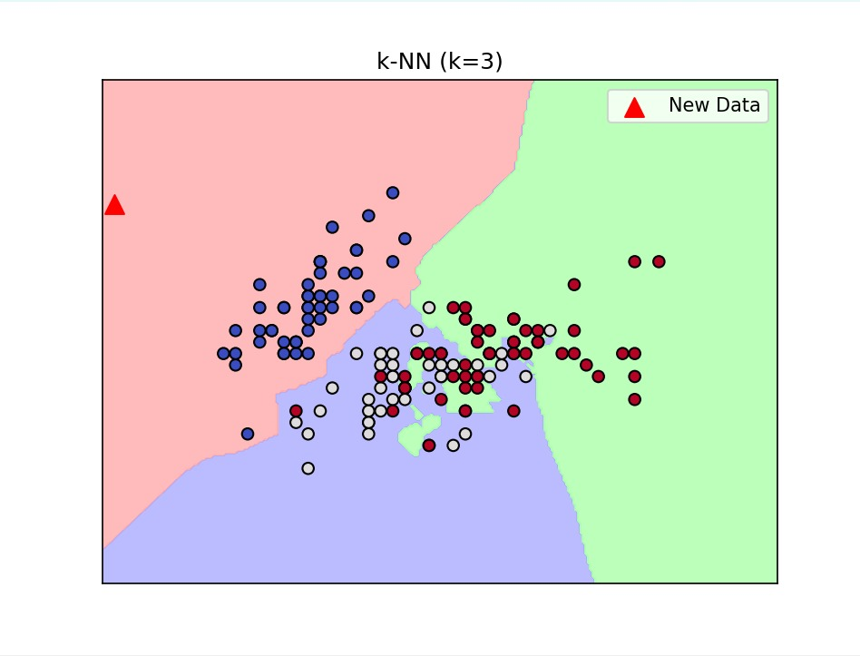

KMeans:

import numpy as np

import matplotlib.pyplot as plt

from sklearn.datasets import make_blobs

from sklearn.cluster import KMeans

n_clusters = int(input("Enter the number of clusters: "))

X, _ = make_blobs(n_samples=300, centers=n_clusters, random_state=42)

kmeans = KMeans(n_clusters=n_clusters, random_state=42).fit(X)

plt.scatter(X[:, 0], X[:, 1], c=kmeans.labels_, cmap='viridis', marker='o', edgecolor='k', s=50)

plt.scatter(kmeans.cluster_centers_[:, 0], kmeans.cluster_centers_[:, 1], c='red', marker='X', s=200, label='Centroids')

plt.title(f'K-Means Clustering (n_clusters={n_clusters})')

plt.xlabel('Feature 1')

plt.ylabel('Feature 2')

plt.legend()

plt.grid()

plt.show()

OUTPUT:

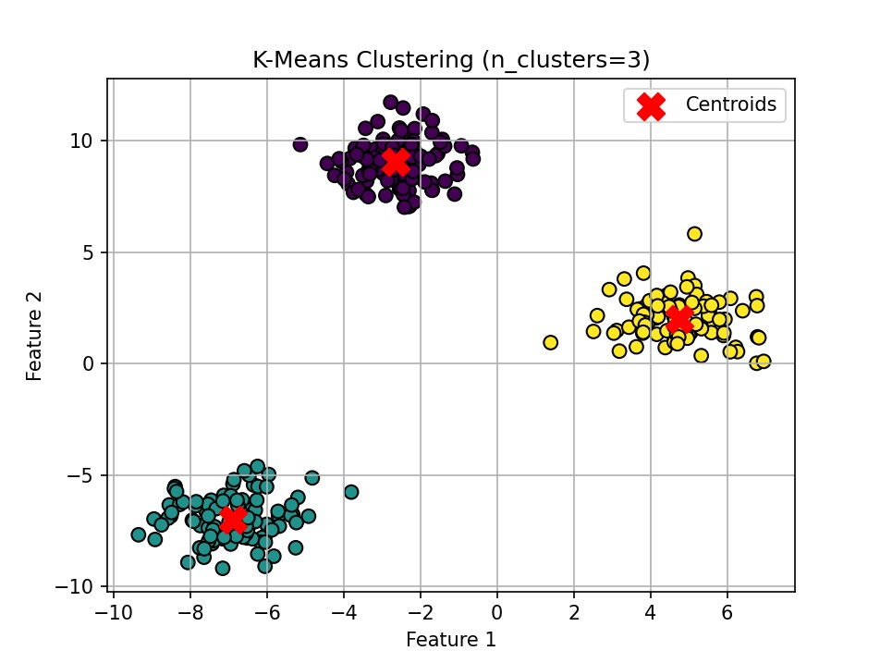

LINEAR REGRESSION

import numpy as np

import pandas as pd

import matplotlib.pyplot as plt

from sklearn.model_selection import train_test_split

from sklearn.linear_model import LinearRegression

np.random.seed(0)

X = 2 * np.random.rand(100, 1) # Independent variable

y = 4 + 3 * X + np.random.randn(100, 1) # Dependent variable with some noise

X_train, X_test, y_train, y_test = train_test_split(X, y, test_size=0.2, random_state=42)

model = LinearRegression().fit(X_train, y_train)

y_pred = model.predict(X_test)

plt.scatter(X_test, y_test, color='blue', label='Actual Data')

plt.plot(X_test, y_pred, color='red', linewidth=2, label='Regression Line')

plt.title('Simple Linear Regression')

plt.xlabel('Independent Variable (X)')

plt.ylabel('Dependent Variable (y)')

plt.legend()

plt.show()

print(f'Intercept: {model.intercept_[0]:.2f}')

print(f'Slope: {model.coef_[0][0]:.2f}')

OUTPUT:

